DEADLINE FOR ELIGIBILITY VERIFICATION: TUESDAY, MARCH 1, 2022 BY 2:35 P.M.
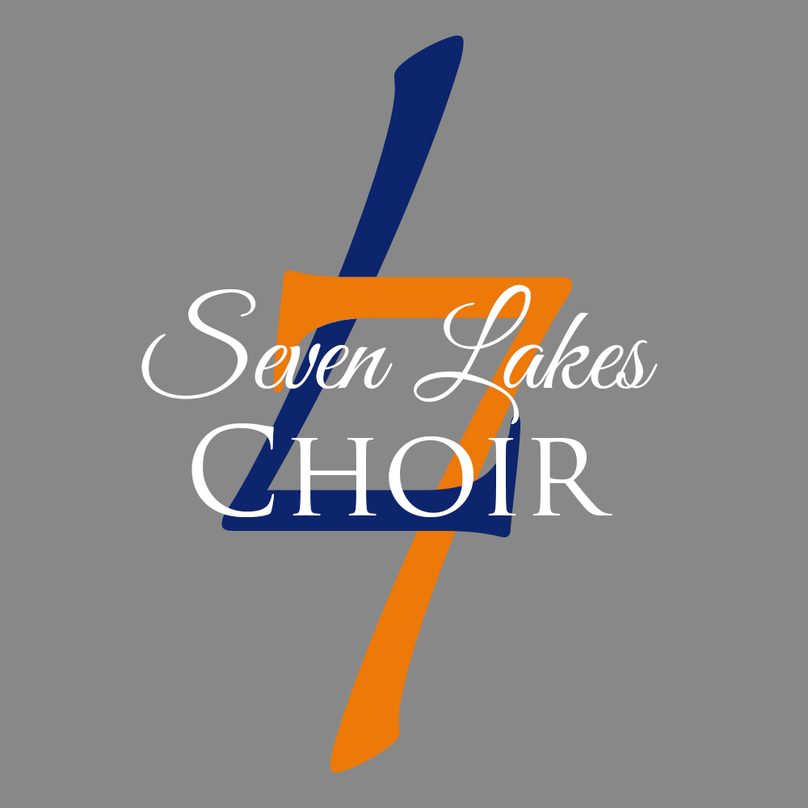CHOIR BOOSTER CLUB
SCHOLARSHIP APPLICATION ELIGIBILITY VERIFICATION FORM
JENNA DAVIS MEMORIAL CHOIR SCHOLARSHIP
Please complete this form with your director and counselor signatures, in that order, and submit to the choir Directors by Tuesday, March 1, 2022 no later than 2:35 p.m. Please make a copy for your records. Once your eligibility has been verified, you will receive an email with a Google Form link to complete your scholarship application. Completed applications and essays are due Friday, April 1, 2022. Scholarship winners will be announced at the Choir Banquet on Saturday, May 14th.
Contact Scholarship Committee Chair, Erick Segarra with any questions @ esegarra@cronustec.com or 281.685.6422.
________________________________________________________________________________________________
Applicant Name: Phone: Email:

_________________________________________________________________________________________
CHOIR DIRECTOR’S USE ONLY

- The applicant is currently a Senior enrolled in the SLHS Choir Program.

YES NO

- The applicant and/or applicant’s family has been a member in good standing of the SLHS Choir Booster Club since October 21, 2021.

YES NO

Director’s Approval Signature:______________________________________________________________

Typed/Electronic Signature (optional):________________________________________________________

Electronic Signature (optional):______________________________________________________________

