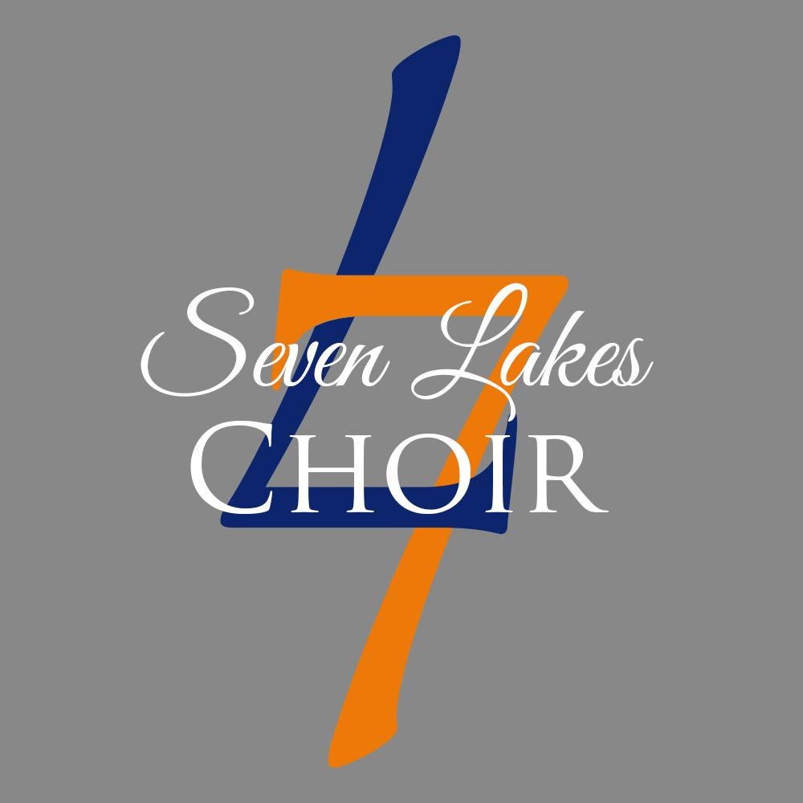
SLHS Choir Senior Scholarship Application
MUSICIANSHIP POINTS FORM
Applicant Name:
CATEGORY | POINTS | FRESH. | SOPH. | JUNIOR | SENIOR
Choir Participation | 1
Chorale | 1
Sensations | 1 | Not Eligible
Choir Council Officer | 2 | Not Eligible
Grade Level/Choir Rep. | 1
District Choir | 1
Region Choir | 1
Pre-Area Choir | 1
Area Choir Auditions | 1
All-State Choir | 2
Regional Solo: Rating I, Class I | 1
Regional Solo: Rating I, Class II | 1
Regional Solo: Rating I, Class III | 1
Regional Ensemble: Rating I, Class I | 1
Regional Ensemble: Rating I, Class II | 1
Regional Ensemble: Rating I, Class III | 1
State Solo: Rating I, Class I | 2
State Solo: Rating II, Class I | 1
State Solo: Outstanding Performance Award | 1
State Ensemble: Rating I, Class I | 1
TMEA Music Merit Scholarship | 1
Subtotal of Points by Year | N/A
4 Year Total of Points to be entered on your Application

